The impacts of customer service – Now for the negatives
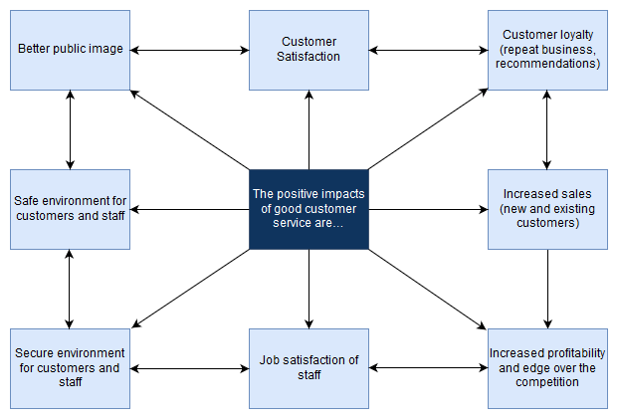

Now for the negatives

Activity
You have seen how good customer service brings about positive impacts for tourism organisations. But the reverse is also true.
Using the diagram above and information from Resource 1, prepare a presentation, which clearly shows the negative impacts of poor customer service.

