Adnodd Llety
Mae yna nifer o dermau a ddefnyddir sy’n berthnasol ar gyfer llety.

Gweithgaredd 1
Isod, gwelir nifer o dermau sy’n berthnasol ar gyfer llety.
Llusgwch bob gair i’w leoliad cywir yn y bylchau sydd wedi’u darparu ar y tudalennau dilynol.

aiter
oom-service
afe
-bed
nline-booking
on-smoking
uality systems
arking
ight porter
ptional extras
partment
itness suite
-box
ar
n-suite
aintor
itz
bis
rading scheme
uest house
heck-in
aravan
nder staffed
alet parking
ostel
acuzzi
ousekeeping
owels
ravelodge
ontins
ntertainment
ift
anager
i-fi
itchen
isit Britain
isney
ll-inclusive
outh Hostel Association
utlins
nternet access
wimming pool
uality care
-ray
oga
arriott
uxury
ids club
npaid
ull board
oorman

Term | Description
A______  A________ | Package holiday with accommodation, meals and some drinks provided  Room in a building used for holidays with one or two bedrooms

Term | Description
B______  B___ | A holiday centre that began soon after world war 11  A facility found within hotels that serves drinks

Term | Description
C_____  C________ | A mobile or static form of holiday accommodation  The system that all hotel guests need to complete in order to access their room

Term | Description
D_______  D________ | An amazing theme park that offers its own hotels  The person who allows access to luxury hotels

Term | Description
E________  E________ | A bathroom that is incorporated into a hotel bedroom  Many hotels provide this for their visitors and guests

Term | Description
F ________  F________ | A package that includes breakfast, lunch and evening meal.  A facility provided for guests who want to look after their bodies

Term | Description
G________  G________ | A type of accommodation that is midway between a B&B and a hotel  A system whereby accommodation is given a rating depending on the facilities and standard it offers.

Term | Description
H________  H________ | Back packers generally choose to stay here because of its low cost and the chance to meet other backpackers/ travellers.  The department that looks after everything domestic within a hotel including cleaning, lost property, laundry.

Term | Description
I____  I________ | A hotel chain originated in France.  Everyone wants this in order to access their e-mails and social media.

Term | Description
J________  J________ | A communal hot pool with bubbles. It’s meant to be therapeutic too.  An American term for caretaker

Term | Description
K_________  K________ | The place where all meals are prepared and cooked  Parents appreciate this as it allows them a break from their children.

Term | Description
L_________  L________ | This is a facility used when there are many floors within the accommodation.  A term associated with 5*hotels

Term | Description
M_______  M________ | The person who oversees the daily running of the accommodation. There may be more than one.  A hotel chain found worldwide

Term | Description
N__________  N________ | The person who acts as watchman throughout the night  All accommodation has adopted this rule

Term | Description
O_______  O________ | Most accommodation providers allow this access to booking.  These can be purchased on top of your basic booking

Term | Description
P_________  P________ | A UK holiday park with resorts located in different locations of the UK.  A service provided to keep your car safely overnight

Term | Description
Q_________  Q________ | Many accommodation providers strive to provide this service in order to get your loyalty.  A method of checking if standards are being met by accommodation providers

Term | Description
R____  R________ | A famous London 5* hotel  Hotel guests can ring the hotel reception or kitchen and order food and drinks that will be delivered to their room.

Term | Description
S__________  S________ | A facility that can be either indoor or outdoor or both whereby guests of all ages can relax or exercise in water.  A facility provided for guests to keep all valuables in safekeeping.

Term | Description
T_________  T________ | An international hotel chain offering budget accommodation.  Hotels provide these for guests to dry themselves after showering/ bathing.

Term | Description
U________  U________ | When there are busy times, accommodation providers may find they are experiencing being this.  Many people working in the not-for-profit organisations associated with accommodation do so voluntarily.

Term | Description
V______  V________ | A personal parking service provided by 5* accommodation providers.  The organisation that promotes the UKs tourism and its accommodation providers worldwide.

Term | Description
W______  W________ | A person who serves you during a meal  The service that allows internet access

Term | Description
X_____  X________ | A games consol that is sometimes available at hotels.  A security scanner that is used by some hotels and other accommodation providers

Term | Description
Y__________  Y________ | The accommodation provider that began as cheap accommodation for young people.  A form of exercise. Classes are often held at leisure Spas located within hotels.

Term | Description
Z_______ | An extra bed often used for children sharing a family room. It can be folded down and stored away.

Gweithgaredd 2
Mae llety yn amrywio mewn maint a graddfa, sy’n dylanwadu ar y math o berchenogaeth.
Allwch chi gysylltu’r math o lety gyda’r ffurf debygol o berchenogaeth o’r rhestr o ddelweddau isod?
Dewiswch y math o berchenogaeth o’r rhestr isod a’i gysylltu â’r ddelwedd addas. Os hoffech fynd gam ymhellach, eglurwch pam eich bod yn credu mai dyma’r ffurf fwyaf tebygol o berchenogaeth.

Cwmni Cyfyngedig Cyhoeddus (PLC)
Unig fasnachwr
Ddim-er-elw
Partneriaeth
Cwmni Cyfyngedig Preifat (LTD)

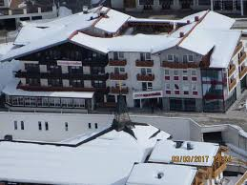

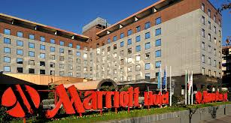
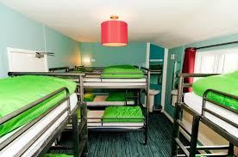

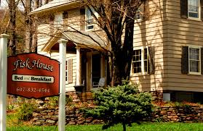
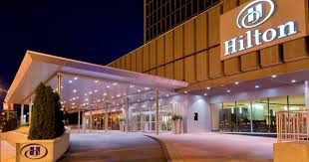

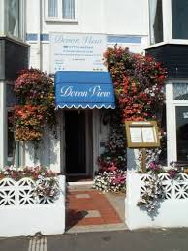
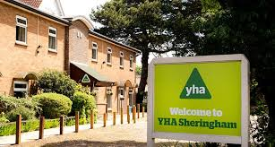

Gweithgaredd 3
Erbyn hyn, rydych yn deall bod llety yn amrywio mewn maint a mathau, a bod amrywiaeth o wahanol fathau o berchenogaeth yn dibynnu ar faint a graddfa.
Cymerwch amser i edrych ac ymchwilio un o’r darparwyr llety canlynol. Dewiswch naill ai:
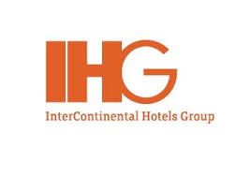

neu

Beth allwch chi ei ddweud am y darparwr llety rydych wedi’i ddewis?
Crëwch ffeil o ffeithiau yn cynnwys tua 200 gair a delweddau i gefnogi eich darganfyddiadau.
Dylech chi gynnwys:
- Math o berchenogaeth?
- Lleoliad?
- Beth mae’r cwmni yn ei berchen? Un math o westy neu fathau gwahanol o fewn y brand?
- Yw’r cwmni hwn yn gweithredu o fewn y DU yn unig?What can you say about your chosen accommodation provider?

