Attractions
Tourist attractions, sometimes known as visitor attractions, are a vital part of the UK’s tourism industry. They are literally places that people are attracted to. There is a wide range of attractions within the UK varying from beautiful beaches to modern theme parks. The UK’s attractions include:
- Museums and galleries
- Historic properties
- Leisure parks
- Wildlife attractions
- Visitor centres
- Steam railways
- Country parks and gardens
- Natural attractions such as mountains and beaches

Some attractions operate within the private sector for profit, e.g. Madame Tussauds; some operate not-for-profit, such as the National Trust. Others are controlled by the public sector, either through local authorities or on behalf of central government.
Attractions are classified as being either natural, built or purpose built. Natural attractions are attractions that have developed naturally through nature. Built attractions are attractions that have become visitor attractions over the years, whilst purpose-built attractions have been specifically built to attract visitors and tourists. Generally speaking, many natural attractions operate within the not-for-profit (voluntary) sector. Built attractions are controlled by the public sector and are subsidised by local authorities or government and purpose-built attractions generally operate within the private sector.

Activity 1
Below is a list and images of popular UK attractions. Can you identify and classify the following attractions under their correct heading? You may need to do some research.

Attraction | Natural, Built or purpose built
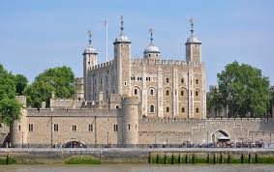
Tower of London
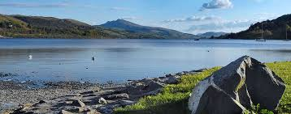
Lake Bala
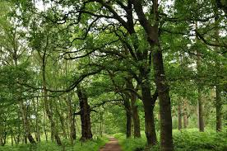
Sherwood Forest
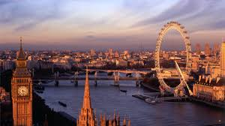
The London Eye

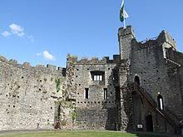
Cardiff Castle
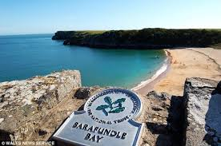
Barafundle Bay
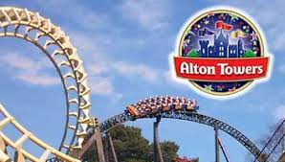
Alton Towers
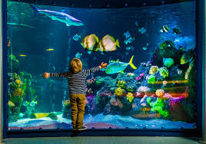
Sealife Centre
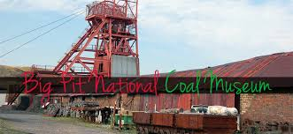
Big Pit Coal Museum

Activity 2
What type of ownership?
Can you identify the appropriate ownership that each of the listed attractions belong to?
Attraction | Ownership – Private, Public, Not-for-profit (Voluntary)?
Tower of London
Lake Bala
Sherwood Forest
The London Eye
Cardiff Castle
Barafundle Bay
Alton Towers
Sealife Centres
Big Pit Coal Museum

Activity 3
Have some fun at research.
In groups of three or four, choose one of the attractions from the list and using the internet, research your chosen attraction in more detail.
Decide who is going to do what to contribute to the research and presentation, that way everyone will have a clear role.
- Tower of London
- Lake Bala
- Sherwood Forest
- The London Eye
- Cardiff Castle
- Barafundle Bay
- Alton Towers
- Sealife Centre
- Big Pit Coal Museum

Present your findings to the class.
Consider the following questions:
Who owns the attraction?
Where is it located?
How many visitors does it attract each year?
How many people does it employ (if any)?
Is it a seasonal attraction? That is, does it only open during a certain part of the year?
What does it offer tourists?
Try to add your own interesting facts
You could use PowerPoint to present or create an information poster and discuss with the class.

