Tourist Information Centres
Tourist Information Centres are one of the most important facilities within the UK tourist industry and often act as the first point of contact for thousands of visitors who rely on them for up-to-date information and advice about the destination they are visiting.
TICs are usually funded by the local council and their staff have detailed knowledge about the local area.
The products and services provided by TICs include:
- Free visitor maps

- Leaflets about attractions and events

- Visitor Cards which allow discount in some shops, attractions and restaurants

- A multilingual staff to offer advice

- Ticket sales to popular attractions

- Ticket sales to tourist transport within the destination

- A gift shop selling souvenirs and locally-produced gifts.

Activity 1
Read the information below about a new way in which technology is helping tourists receive information about the destination.

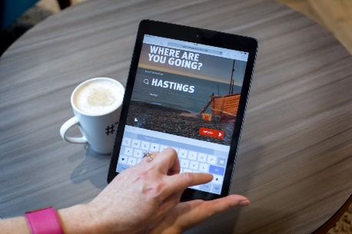

Realtimetravelguide
Realtimetravelguide is an initiative designed to demonstrate how tourist and visitor information centres can utilise new technology to drive growth by providing an excellent modern real-time service to visitors, businesses and wider local communities.
This initiative will deliver real-time visitor information via Twitter. Participants including tourist information centres (TICs) are encouraged to engage with and support local businesses to share their announcements, offers, updates and reasons to visit specific locations.
Suggest how TICs can use a range of modern technology to help visitors
- before they visit a destination and

- while they are staying in the destination

