Putting it all together
You have been learning about different characteristics of tourists and tourist types. Now let’s see if you can ‘build a tourist’.
Below you will find a series of tourist types. From the images, select suitable items that identify either a leisure or business tourist type. Then move on to build tourists of different ages and from different cultures.
The characteristics of each different tourist type are given below.
Different Types of tourists
- Leisure – these are tourists who travel simply for leisure purposes. A holiday, a short break, a weekend away, whatever it is, it is not related to any work purpose, they are doing it in their own time and for their enjoyment.
- Business – quite the opposite to above. These tourists are away from home on business. They may take part in leisure activities whilst they are away, but the primary purpose of their visit is work/business.
- Different ages – this can be broken down into
    - Children – babies, toddlers, older children and teenagers
    - adults – young adults, middle-aged adults, senior citizens
- Different cultures – people from different cultures expect to be respected and have their beliefs and behaviours understood. British culture is very different to Chinese culture, e.g. the foods are different, the traditions are different. Culture makes us what we are.

Activity 1
Create the tourist types – 1 male or 1 female, 1 leisure and 1 business tourist. Select appropriate clothes and accessories appropriate to your types of tourist. Drag the items to the body shape. Annotate your tourists as you build and create them, that is, explain in note form your choice of items.
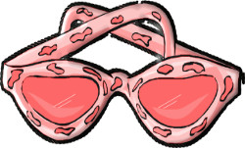
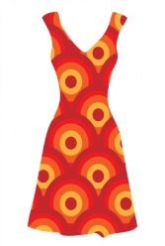
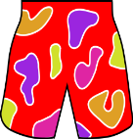
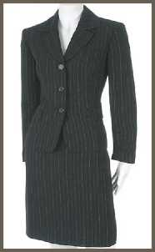
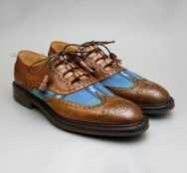
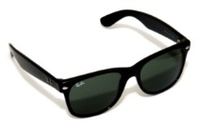
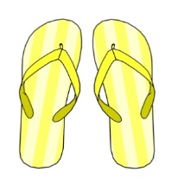
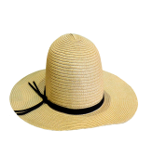

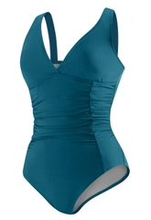

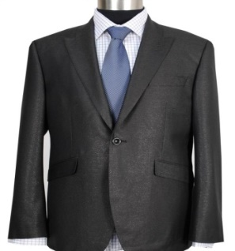

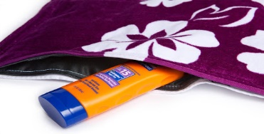

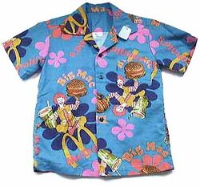

Activity 2
You will now have the opportunity to demonstrate your understanding of different types of tourist.
Describe your chosen tourist types, giving such information as to
- the tourist’s age and gender
- where he or she is going
- with whom he or she will be travelling with, if anyone
- how the tourist will get to the chosen destination
- what he or she will be able to do when at the destination

Activity 3
Over to you ...
Decide on a destination you would like to visit for a holiday.
- Where would you choose to go? Why?
- What would you need to take away with you if you were going to be a leisure tourist?
- Who would be going with you?
- What do you do in your leisure time at your chosen destination?

Create yourself using a poster to explain the above bullet points.

